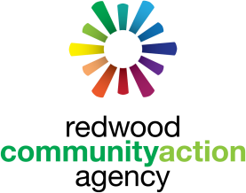
NEEDS ASSESSMENT SURVEY

Humboldt County residents are invited to share their views regarding the needs of low-income members, of all ages, in our community. The information you share will be gathered and
contribute to the RCAA Needs Assessment for Redwood Community Action Agency’s 2024/2025 Community Action Plan.

Date: Click or tap to enter a date.
Your name: Click or tap here to enter text.
Your email address: Click or tap here to enter text.
Organization, if applicable: Click or tap here to enter text.
Town you live in: Click or tap here to enter text.
- What do you think are the problem(s) impacting low-income residents of Humboldt County?
Click or tap here to enter text.

- What do you think are the causes of these problem(s)?

Click or tap here to enter text.

- Are you aware of anyone or any program(s) that address these issue(s)?

Click or tap here to enter text.

- What suggestion(s) do you have for addressing the problems?
Click or tap here to enter text.

- Do you have any other information or concerns that you would like to share?
Click or tap here to enter text.

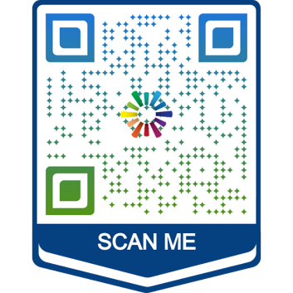

For more information or to send in completed surveys please emailed Rachel Wild at rwild@rcaa.org or call (707)269-2003.

You can also scan the QR code to complete the survey online.

